Nicholas McClellan

December 6th, 2019

EENG310

Matlab Assignment 6

1. Code is attached in the .zip file.

2. Figure 1: Versus Time; Figure 2: Spectrogram

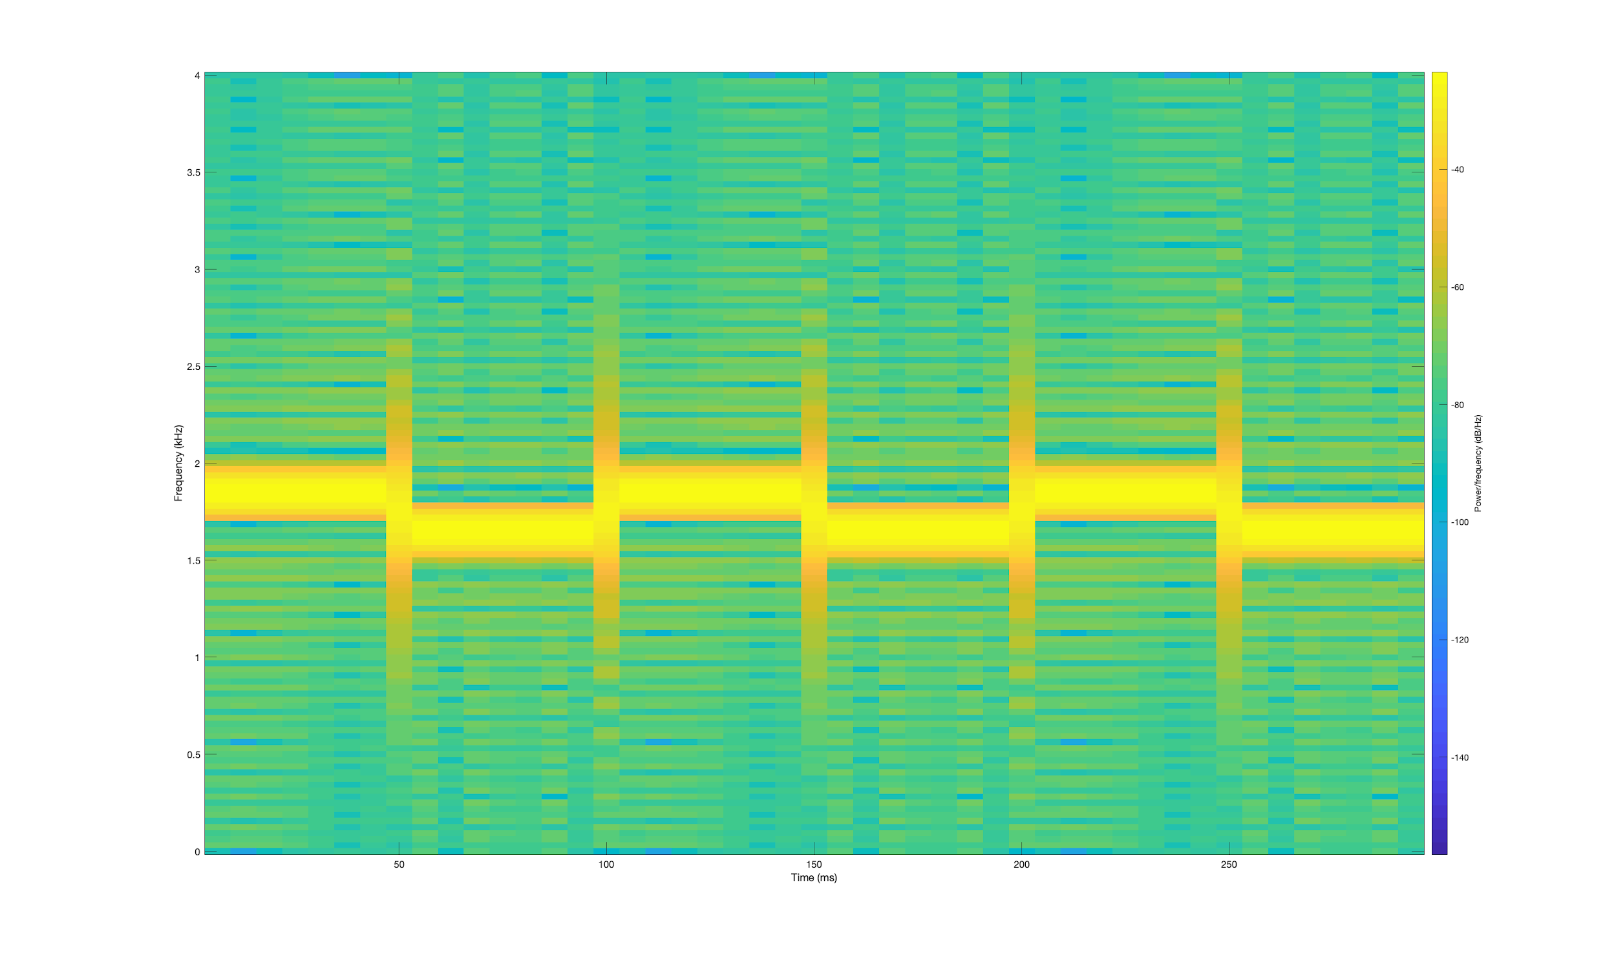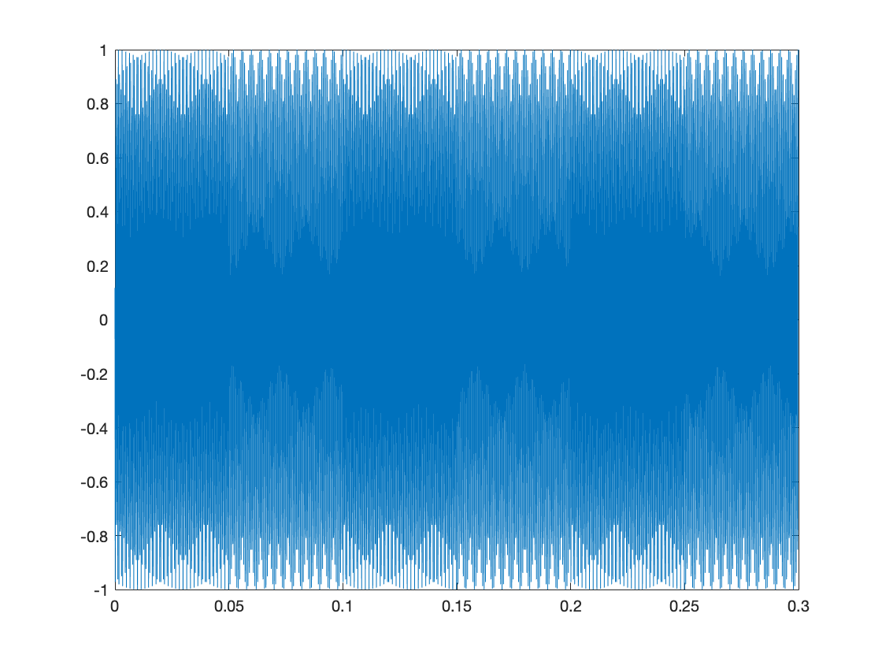

3. Code is attached in the .zip file. (Not exactly sure what else is a deliverable for this problem?)

4. Code is attached in the .zip file. Figure 1: Spectrogram.

5. Code is attached in the .zip file. Figure 1: Filter1; Figure 2: Filter2.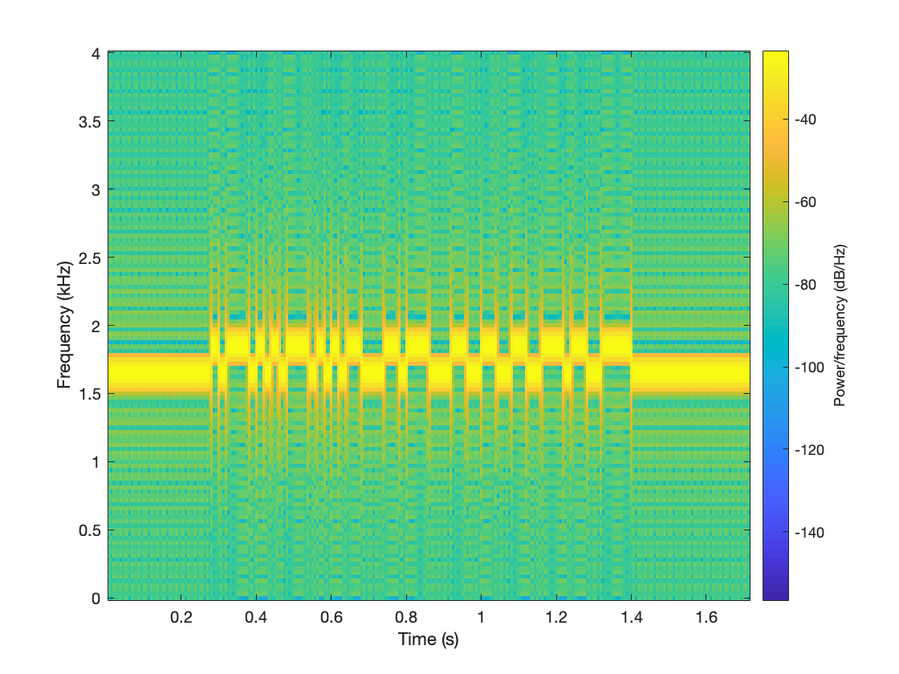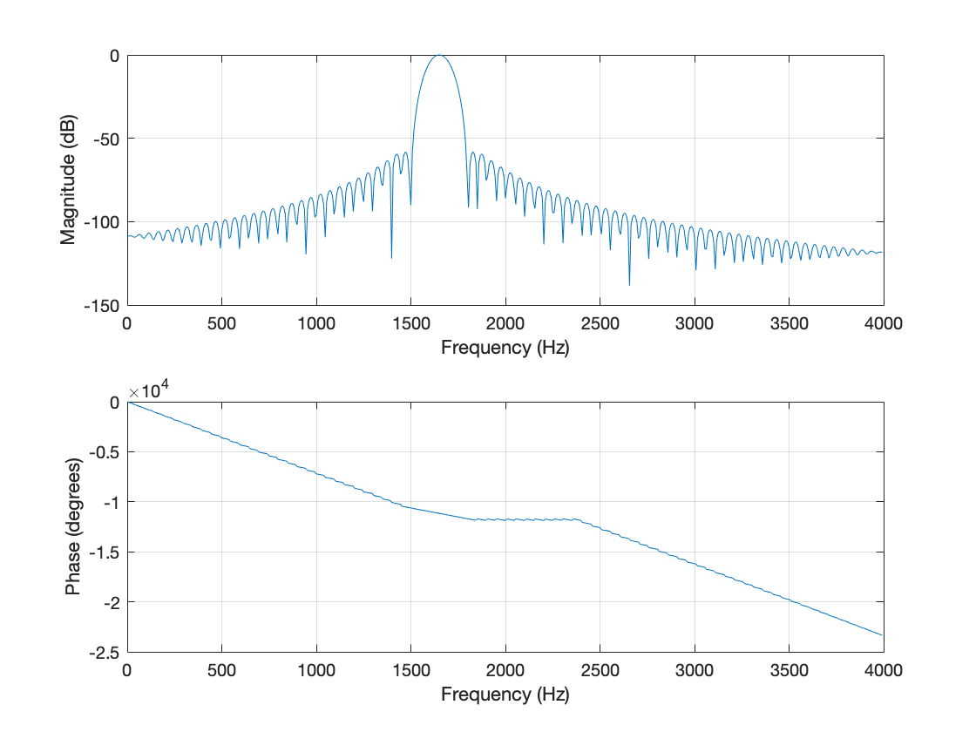

6. Code is attached in the .zip file.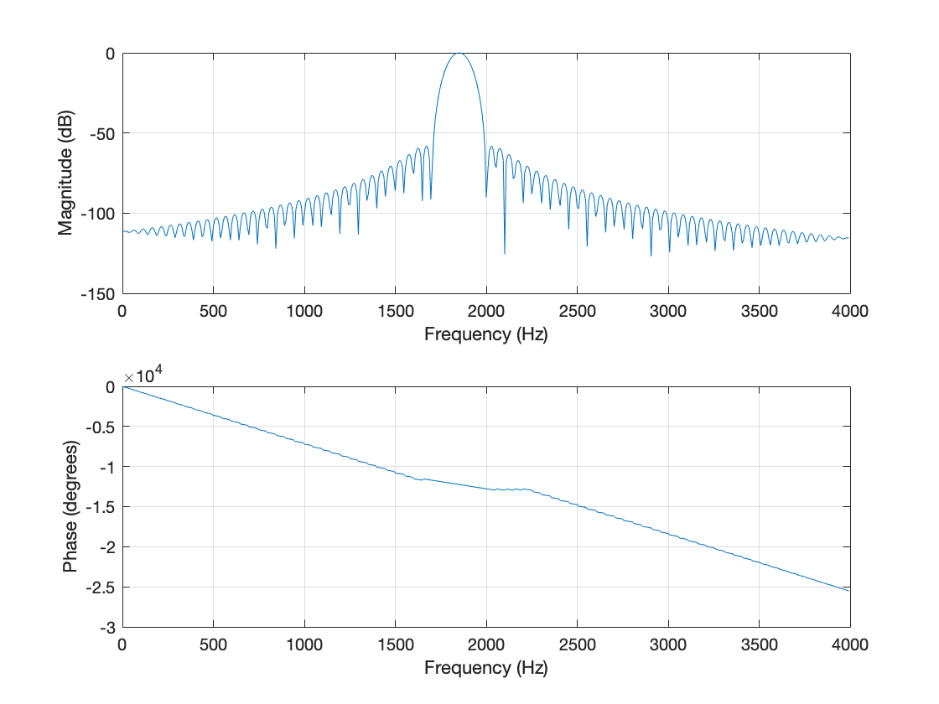

7. Code is attached in the .zip file. Figure 1: Outputs on the same graph (I am really confused about what this graph represents)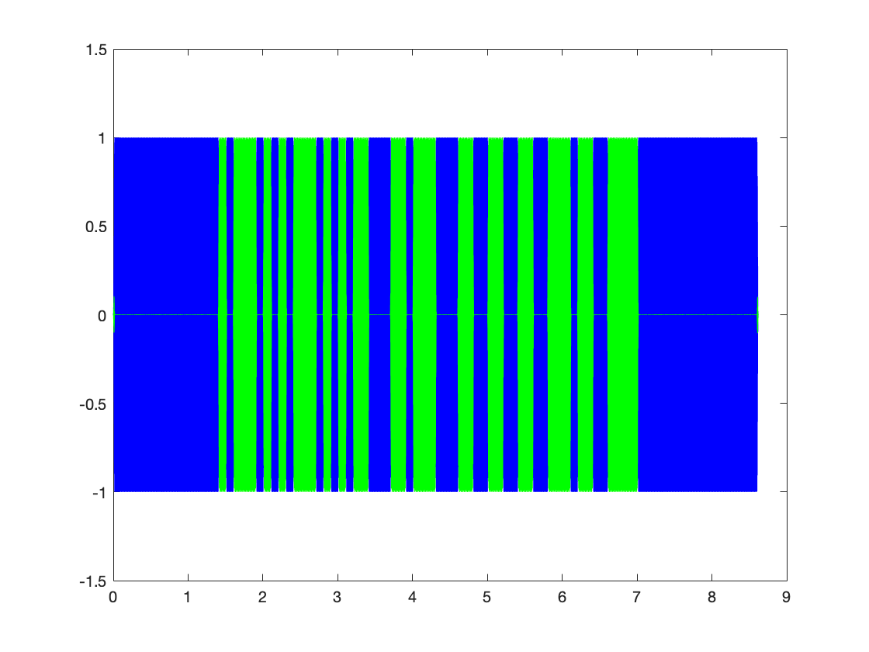

8. Code is attached in the .zip file. Figure 1: Filter1; Figure 2: Filter2.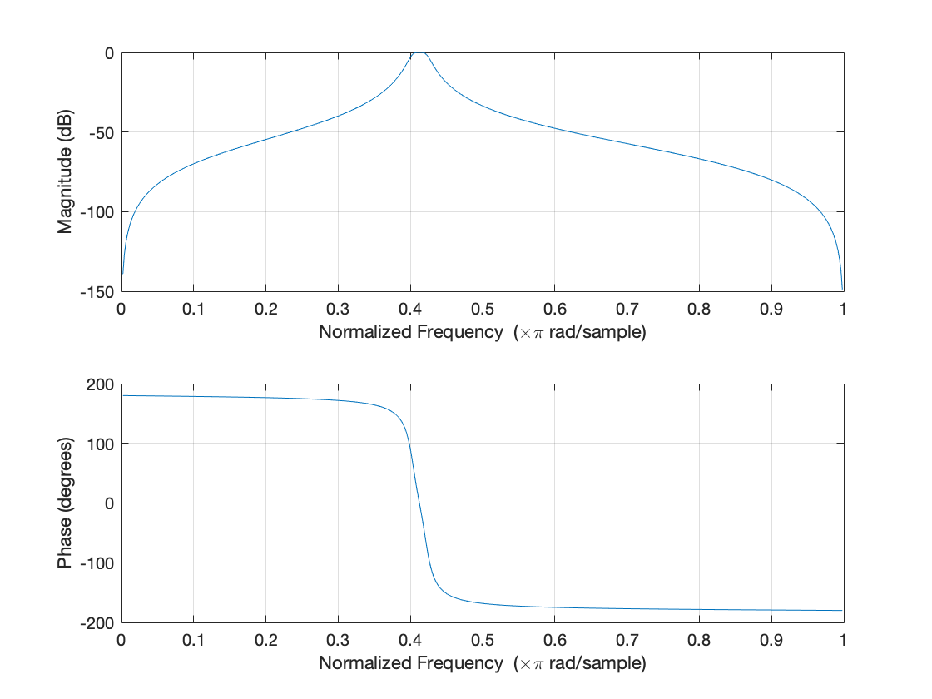

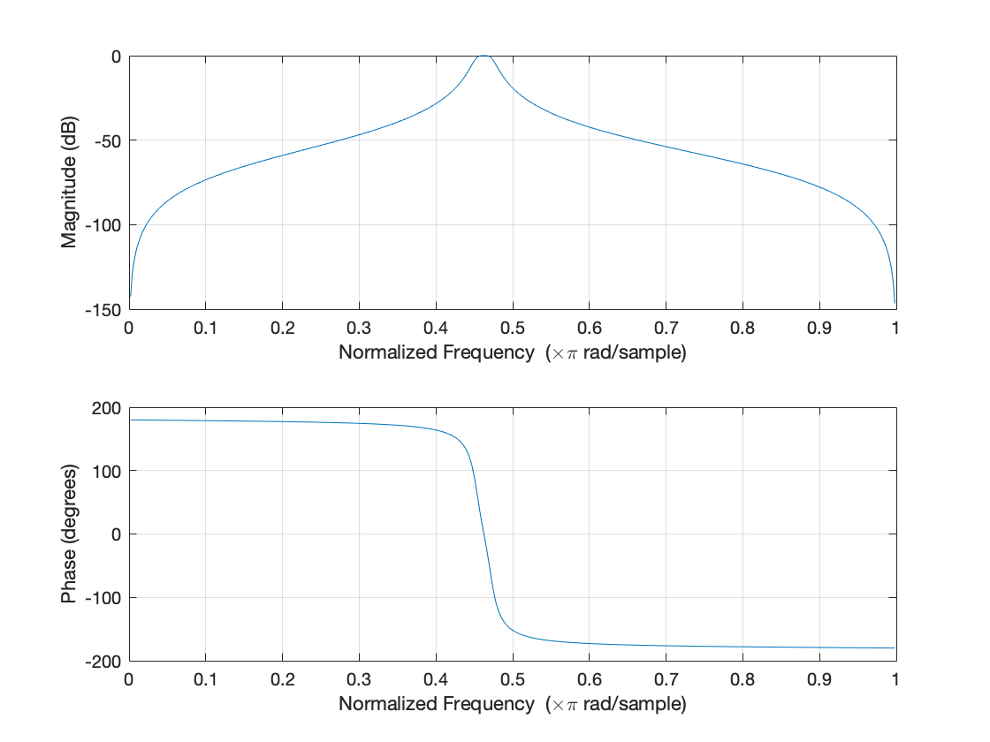

9. Code is attached in the .zip file.

10. 